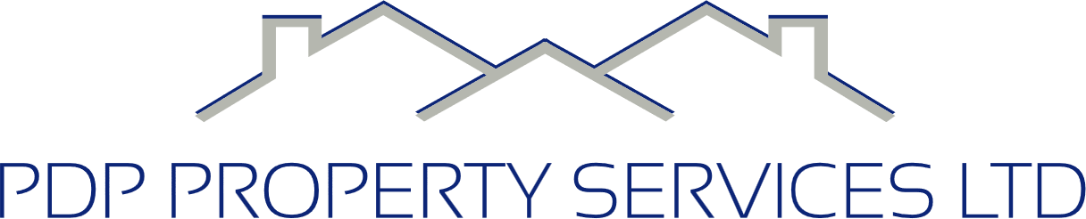
Quality Policy

Introduction
At PDP Property Services Ltd, quality is central to everything we do.
We are committed to delivering safe, reliable, and compliant building, refurbishment, and maintenance services for public-sector clients across the North West.
Our approach is built on professionalism, clear communication, and consistent standards — ensuring every project meets client expectations and relevant industry requirements.

Our Commitment to Quality
We aim to provide high-quality workmanship, efficient project delivery, and excellent customer service through:
- Careful planning and preparation before works begin
- Competent, trained personnel carrying out all tasks
- Clear communication with clients throughout each project
- Use of reputable suppliers and accredited subcontractors
- Regular monitoring of work to maintain high standards
- A focus on safety, sustainability, and long-term performance

Management Responsibility
The Managing Director is responsible for ensuring that this Quality Policy is implemented effectively across the business.
Our Project Managers oversee day-to-day delivery, ensuring that:
- Work is completed to specification
- Compliance requirements are met
- Site standards remain consistent
- Any issues are identified and resolved quickly
Quality expectations are communicated to all employees and subcontractors as part of our induction and ongoing training.

Working With Clients and Framework Partners
We work collaboratively with public-sector organisations, framework providers, and supply partners to achieve shared goals.
This includes:
- Understanding client requirements clearly
- Providing honest and accurate information
- Following framework specifications and reporting processes
- Ensuring transparency in pricing, progress, and delivery
We aim to build long-term relationships based on trust, reliability, and consistent performance.

Continuous Improvement
We review our processes regularly to identify opportunities for improvement.
This includes:
- Internal audits and site inspections
- Reviewing client feedback
- Learning from defects, near misses, and lessons learned
- Updating training, procedures, and documentation where required
Our goal is to continually improve the quality, efficiency, and value of the services we provide.
Review
This policy is reviewed annually, or sooner if legislation, industry standards, or company procedures change.
Signed:
Michael Acton
Managing Director
PDP Property Services Ltd

